**Practical No: 1**

**Aim: Study and implementation of Infrastructure as a Service.**

**sudo apt-get update**

**sudo useradd -s /bin/bash -d /opt/stack -m stack**

**echo "stack ALL=(ALL) NOPASSWD: ALL" | sudo tee /etc/sudoers.d/stack**

**sudo su - stack**

**sudo apt install git -y**

**git clone** [**https://opendev.org/openstack/devstack.git**](https://opendev.org/openstack/devstack.git)

**cd devstack**

**sudo nano local.conf**

[[local|localrc]]

# Password for KeyStone, Database, RabbitMQ and Service

ADMIN_PASSWORD=bhavans

DATABASE_PASSWORD=$ADMIN_PASSWORD

RABBIT_PASSWORD=$ADMIN_PASSWORD

SERVICE_PASSWORD=$ADMIN_PASSWORD

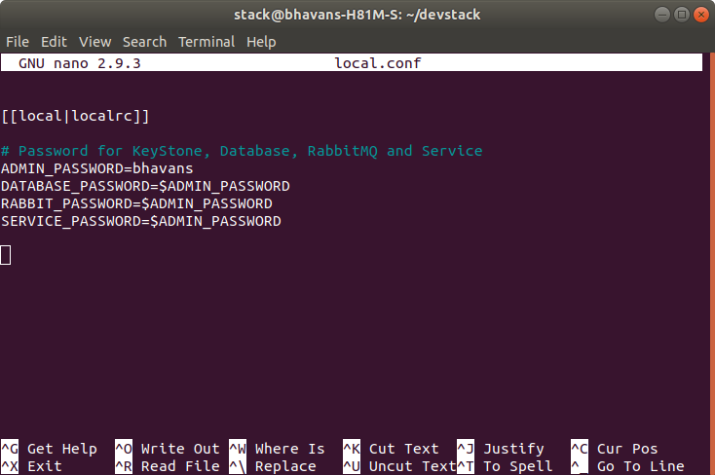

type ctrl+s to save and ctrl+x to exit.

**sudo chown -R stack /*opt/stack/***

**sudo apt install python3-testresources**

**sudo pip install --ignore-installed httplib2**

**sudo pip install --ignore-installed simplejson**

***./stack.sh***

At the very end, you should see output similar to this:

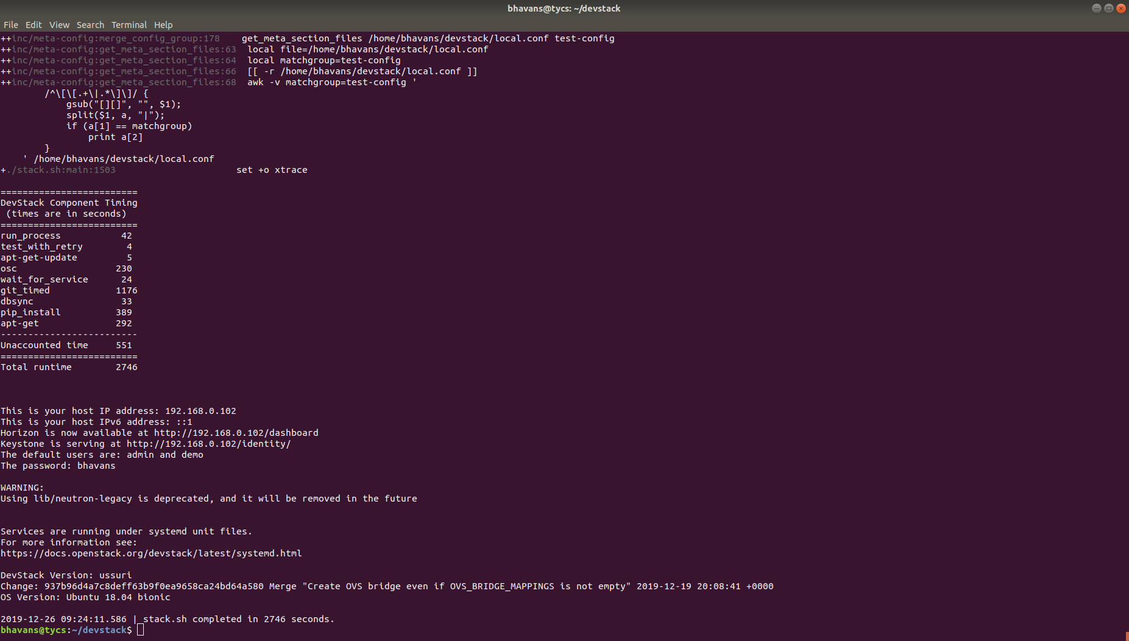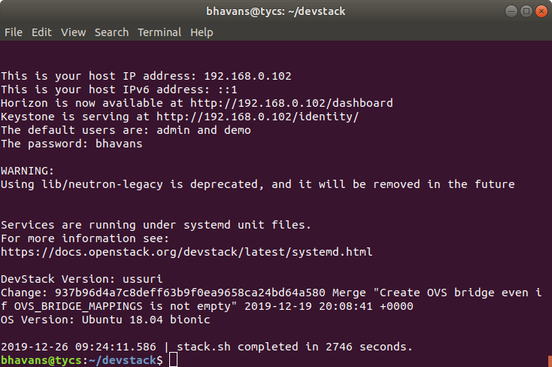

Open a web browser. Go to localhost and login with admin as username and password that you have set.

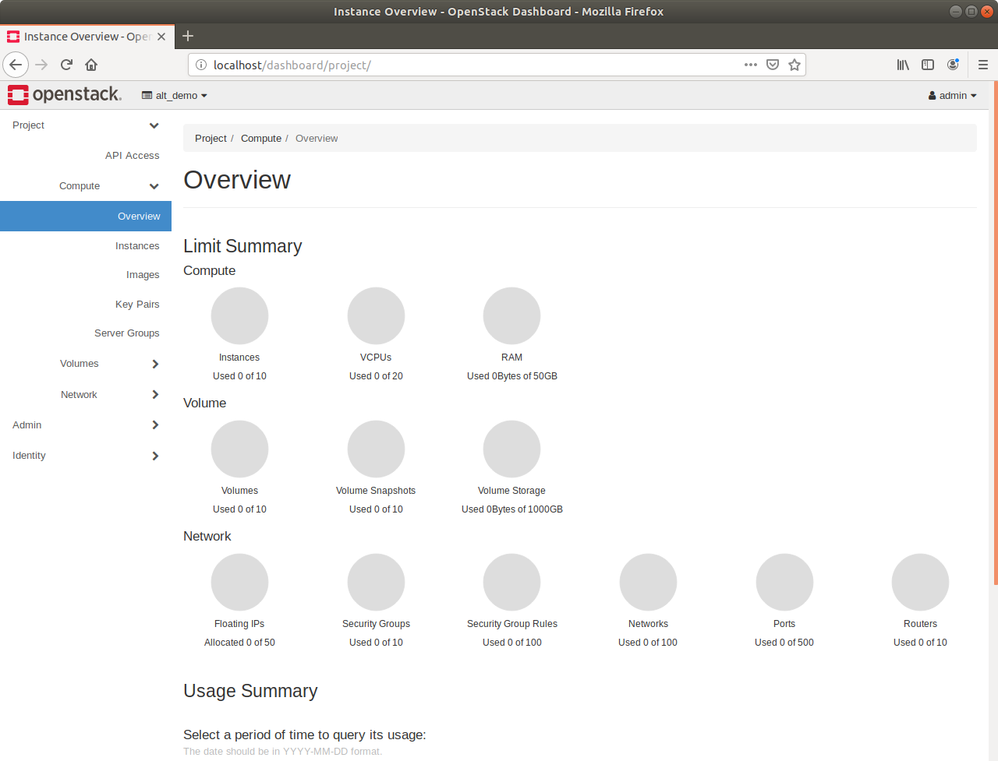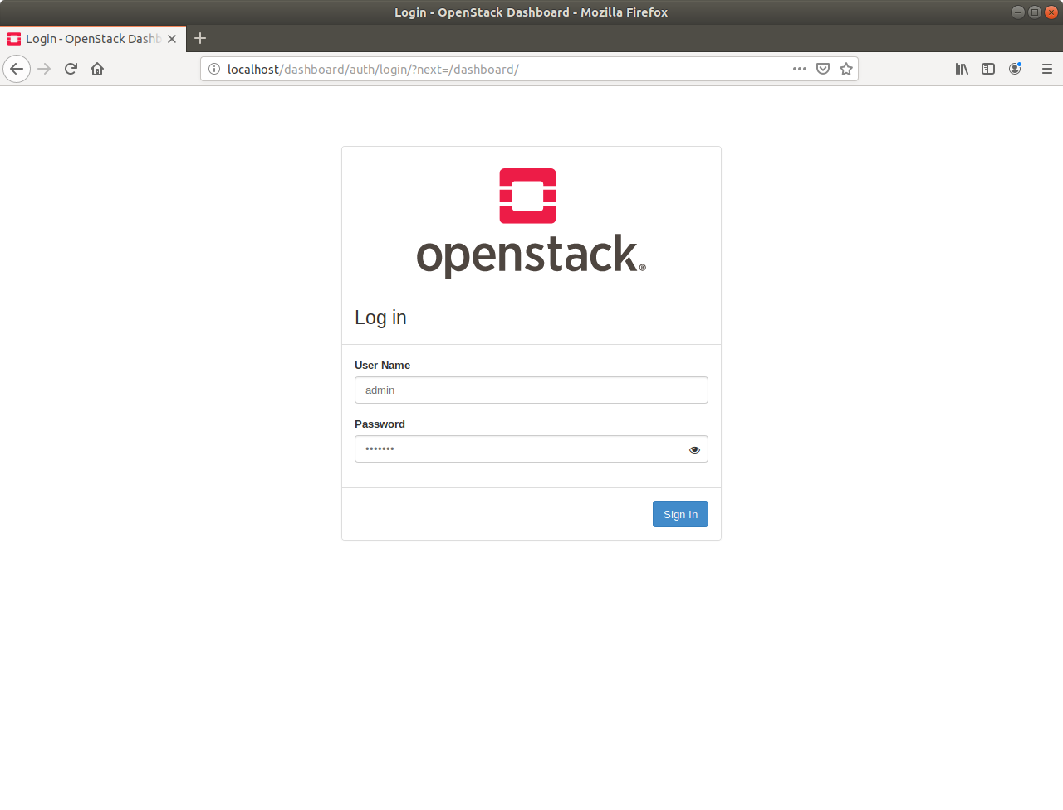

***-----------------------------------------------------------------------------------------------------------------------------------------------***

***#erros***

***#virtualenv error***

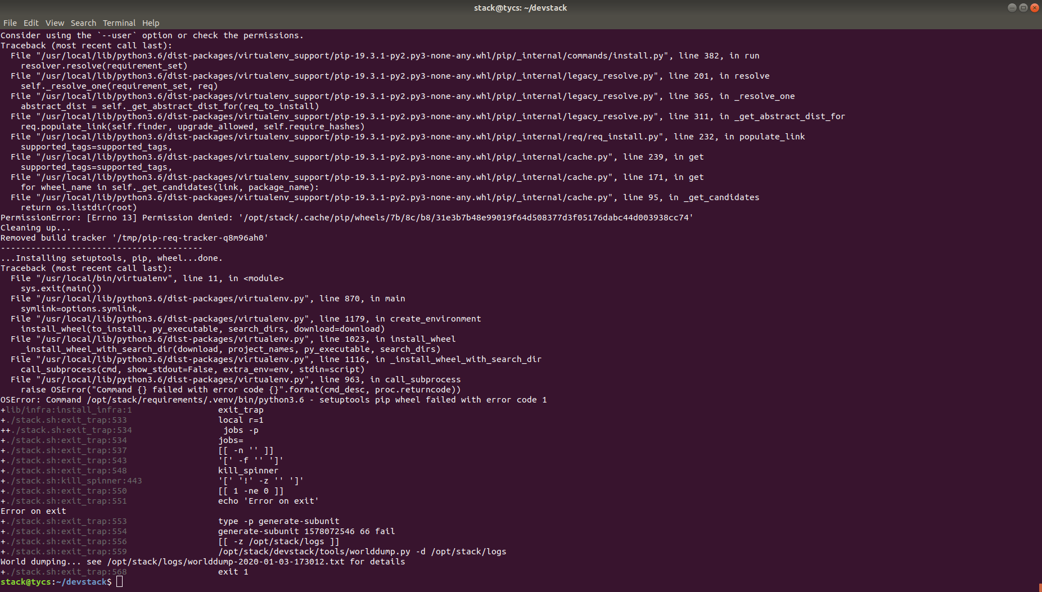

***sudo virtualenv /opt/stack/requirements/.venv***

***sudo chown -R stack /opt/stack/***

***sudo rm -vrf /var/lib/dpkg/lock***

***./stack.sh***